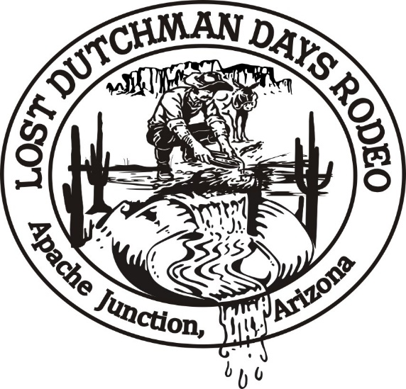
2024 Lost Dutchman Days Royalty Pageant

Thank you for submitting your application to complete for the 2024 Lost Dutchman Days Royalty! Below you will find a tentative schedule of events for the day along with other pertinent information. Times on the schedule may need to be adjusted based on number of contestants.

All contestants will be required to compete in horsemanship* including a set pattern, pushing cattle, flag run and presentation run (hot lap). There will be one pattern for Junior Teen competitors and a separate pattern for Senior Teen and Queen competitors. The patterns are below. Horsemanship attire will be rodeo Queen attire.
*There will be a minimum horsemanship score to qualify to hold an LDD Queen title.

You will also be required to complete a private interview with the judges. The private interviews will be held at the Elk’s Lodge which is right up the road from the rodeo grounds. Interviews will be held immediately following horsemanship and prior to lunch. Interview attire will be jeans and a jacket (professional).

After lunch we will have a short welcome, introduction of contestants and move right into speeches. The Lost Dutchman Days Royalty Pageant does not require leather dresses for speeches but contestants should be dressed in long, formal type queen attire. Speech topic is anything EXCEPT rodeo.

When speeches are complete each contestant will be asked to model as they come up on stage for impromptu questions. Contestants may remain in their speech attire.

This will complete the competition. Winners will be announced as soon as the current royalty’s outgoing speeches have concluded and the judge’s scores have been tallied.

Please don’t forget each contestant is responsible for bringing 1 silent auction item.

Addresses:
Apache Junction Rodeo Grounds: Apache Junction Elks Lodge:
1590 E Lost Dutchman Blvd, Apache Junction, AZ 85119 2455 N Apache Trail, Apache Junction, AZ 85119

2024 Pageant Schedule
8:00 Arrive at Apache Junction Rodeo Grounds for brief meeting among contestants
8:15 all contestants will prepare themselves and horses for warm up (20 minutes total on warm up then tack check with Royalty Director & Coordinator)
9:00 Junior Teen Queen Horsemanship competition
9:30 Senior Teen Queen Horsemanship competition
10:00 Queen Horsemanship competition
11:00 Personal Interview with Judges at Elks Lodge

12:00 Lunch break at Elk’s Lodge
1:30 pm Welcome and Contestant introduction (this will include the Little Miss Contestants)
2:00 Introduction of Visiting Royalty
Modeling
Impromptu Questions
3:00 2023 Queens End of Year Speeches
3:30 Crowning of Queens in waiting and Coronation for Little Miss
Photos
Highest bid winners of Silent Auction will be announced

Note: The 2024 Queen, Sr. & Jr. Teen Queens will remain “In Waiting” until the 2023 LDD Royalty steps down at the crowning ceremony at the 2024 LDD Sunday Pre-Rodeo ceremony. At that time, the queens will be presented as the 2024 Royalty Court and they will be introduced and do the National flag presentation.
The Little Miss LDD Queens will immediately (pageant day) take on their title for 2024.

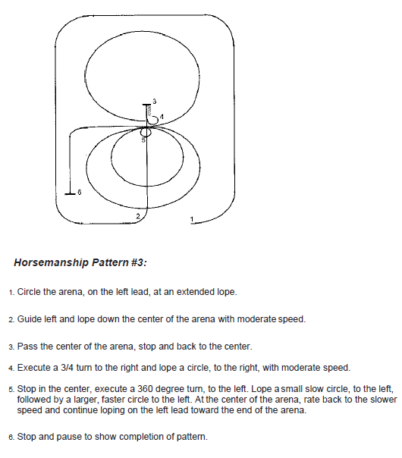
Senior Teen and Queen Pattern

Junior Teen Queen Pattern

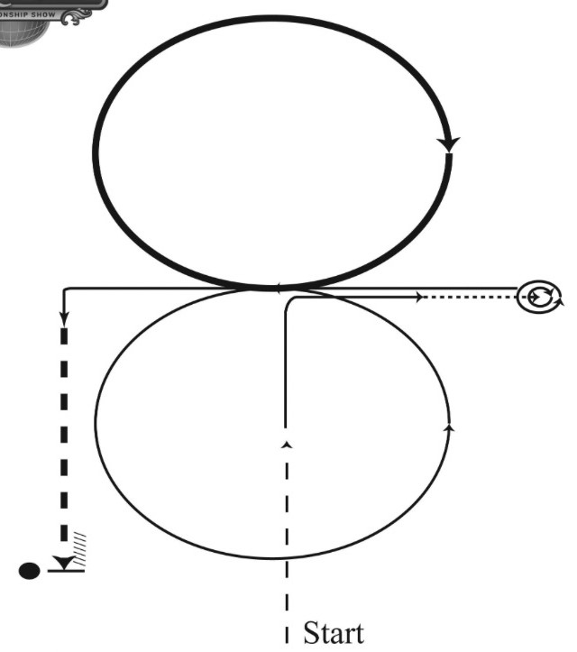
- Enter arena at a jog. Jog ½ way to center. Lope to center and make a square corner on the right lead.
- Walk. Stop and hesitate for approximately 5 seconds for inspection.
- Execute a 360° turn to the left.
- Lope on left lead to center, continuing into a cadenced circle to the left.
- Change leads and lope a circle with speed to the right.
- Change leads and make a semi-square corner.
- Extend jog to marker. Stop and back.
NOTE: The drawn description of this pattern is only intended for the general depiction on the pattern.
Contestant should utilize the arena space to best exhibit their horses.

